There seem to be issues with the Flask server. It may have to do with the fact that each graph in the dashboard is made using a separate function that calls a different Flask route that performs SQL queries. For example, here is one attempt at opening the file:





As seen, the bottom two graphs actually load, while the top does not. Sometimes, only the bottom one will. A 500 error occurs on the teams/winpct route (the one that makes the first graph).

The command line interface shows this:



Note that the pitching route then is accessed fine. The batting route is then also accessed, so that the pitching graph appeared first, despite the fact that the pitching route is called in the code after it.

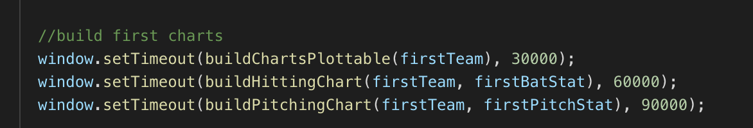

The functions are called in the built in setTimeout function in an attempt to space them out and not overload the SQL server. It seemed to have some aid when first applied in getting anything to load.

Clearly, by the nonsequential GET operations, the methods are being called either in parallel or nonsequentially. It could be something to do with the d3.json function that each method uses. As support for this, the sized div seems to always appear, which is created in buildChartsPlottable before d3.json is used, indicating the problem is arising with multiple uses of that function. A different json loading function could perhaps be found, but none has been identified as of now. Also, changing the data loading strategy so that only one call is made per page would have worked.